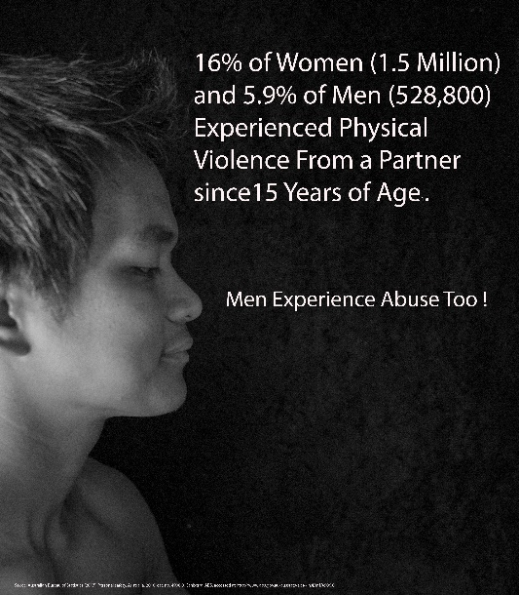
RESEARCH: TASMANIAN MALE VICTIMS AND SUPPORTING SERVICE PROVIDERS EXPERIENCE OF DOMESTIC VIOLENCE.
Research study
The majority of victims of Domestic Violence (DV) are women and children. However, there are also a significant number of men who are or have been victims of abusive Heterosexual relationships. This research aims to learn about the phenomenon of males as victims of Domestic Violence.
If you or someone you know has been a male victim of Domestic Violence, and you are willing to share your view and experience, please contact Paul Campbell on 95415794@student.westernsydney.edu.au or 0417105336. Interviews are confidential and no participant will be identified in the research.
Have You or Someone You Know Been In a Domestic Violence Relationship?

Men’s Line - 1300 22 46 36
LifeLine – 131114
Beyond Blue - 1300 78 99 78
Mental Health Help Line - 1800 332 388

Contact:
PAUL CAMPBELL
B.SOC.SCI (PSYCH, CRIM); P.GRAD.DIP FORENSIC PSYCHOLOGY; P.GRAD.CERT (LEGAL AND PENAL CONTEXTS); GRAD. CERT. AUTISM DIAGNOSIS

95415794@student.westernsydney.edu.au
Mobile: 0417105336
Ethics Approval: H14554

Participant Information Sheet – General (Specific)- Service Provider
Project Title: Tasmanian Men and Service Providers Experience of Family Violence
Project Summary: You are invited to participate in a research study being conducted by Mr Paul Campbell, Dr David Lim, Dr Tinashe Dune, and Dr Jeanna Sutton. This research aims to learn about the experience of males as victims of domestic violence and the experience of service providers who have assisted Males who report being victims of domestic violence in heterosexual relationships.
How is the study being paid for? - There is no direct funding received for this study. This is a PhD project and Mr Paul Campbell receives the standard research training program funding from the Australian Government for tuition fees offset and an allowance related to ancillary cost (e.g. printing).
What will I be asked to do? - You will be asked to meet with the researcher at a location (possibly a local GP clinic) close to where you reside or work, for a short screening interview, which takes no more than 15 minutes, to assess your eligibility to participate, and a one-to-one, in person confidential interview which takes approximately 60-90 minutes. At the screening stage you will be informed about how the information you provide in this study will be used so that your privacy is maintained. There are instances where the researcher must disclose information, such as when there may be harm to children – you will be informed of these exceptions at screening also. The interview consists of both closed and open-ended questions to explore your experience and opinion about males as victims of domestic violence. We will provide you with a copy of the questions 3 days prior to the interview.
How much of my time will I need to give? - The screening questions will take about 15 minutes. The interview will take approximately 60-90 minutes to complete the one-to-one interview.
What benefits will I, and/or the broader community, receive for participating? - There will be no direct benefit to you or your organization from your involvement. However, the findings of the project will enable researchers, clinicians and service providers to better understand men’s experience which will be used to inform future research in this area as well as possibly education material for service providers and/or policy in this area.
Will the study involve any risk or discomfort for me? If so, what will be done to rectify it? - There may be a risk associated with participation in this project. You may feel that some of the questions we ask are stressful or upsetting. If you do not wish to answer a question, you may skip it and go to the next question, or you may stop immediately. If you become upset or as a result of your participation in the research project, you must let Mr Paul Campbell who is conducting the interview and screening know so that we can assist you immediately. Mr Paul Campbell is an experience registered psychologist. We have also organise one free session with a counsellor for you to further discuss the issue, if you want to. You can contact Ms Bev Ernst, Counselling Psychology Practice at 64 Invermay Rd, Launceston on 0448 347933.or Ms Louise Dewis, Psychology Works, 8th Floor, 39 Murray St, Hobart on (03) 62343555. In addition, a list of support contact details will be provided to you at the screening and interview. You are also encouraged to speak to your GP and therapist if you experience distress, have questions about whether to participate in this study and how that might affect you.
If at any other time you feel discomfort, you can contact Beyond Blue on 1300 22 4636 or Lifeline on 13 11 14.Please note that Mr Paul Campbell is a registered psychologist and hence a mandated notifier under the Family Law Act 2004. If the participants have provided during the interview specific information regarding illegal or unlawful activities such as abuse of children, Mr Paul Campbell is obliged to report to the relevant authorities for crime that may have been committed. We will provide participants with a list of general questions to be asked at the scheduled interview 3 days before the event.
How do you intend to publish or disseminate the results? - It is anticipated that the results of this research project will be published and/or presented in a variety of forums. In any publication and/or presentation, information will be provided in such a way that the participant cannot be identified, except with your permission. Information will be deidentified and the results will not be localised to the extent where it is possible to identify any person.
Will the data and information that I have provided be disposed of? - Only Mr Paul Campbell who is conducting the screening and interview will have access to the personal data (name and contact number) you directly provide. The other named researchers will only have accessed to de-identified data. Any reports or publications based on this research will be presented as aggregate data and will not identify. A copy of the summary of the results from this research and a chance to review the final product following the conclusion of the project will be sent to you via post or email. Please advise the researcher if you do not wish to obtain a copy of the summary.
Please be assured that only the researchers will have access to the raw data you provide and that your data will not be used in any other projects. Please note that minimum retention period for data collection is five years post publication. The data and information you have provided will be securely disposed of.
Can I withdraw from the study? - Participation is entirely voluntary and you may, without penalty, decline to take part, or withdraw from the research at any time during the screening or interview, without providing an explanation. You may also refuse to answer any question at the screening or interview. If you do participate you can withdraw at any time without giving reason up until the stage when you are provided with a copy of your interview transcript. You will note in the transcript that we will have removed all potentially identifiable data (e.g. name or place). If you wish instead to correct the transcript, you can. If you do choose to withdraw, any information and data that you have supplied up until the checking of transcript stage will be destroyed. After the checking of transcript stage, all the de-identified transcripts will be analysed together therefore it will not be possible to isolate the data that you have contributed. To withdraw from the project, simply let Mr Paul Campbell who is conducting the screening and interview know, or contact any of the researcher supervisors.
Can I tell other people about the study? - Yes, you can tell other people about the study by providing them with the Chief Investigator’s contact details. They can contact the Chief Investigator to discuss their participation in the research project and/or to obtain a copy of the information sheet.
What if I require further information? Please contact the chief investigator Mr Paul Campbell (95415794@student.westernsydney.edu.au or 0417 105 336) or Dr David Lim (david.lim@westernsydney.edu.au or 0429 922 033) should you wish to discuss the research further before deciding whether or not to participate.
What if I have a complaint? - If you have any complaints or reservations about the ethical conduct of this research, you may contact the Ethics Committee through Research Engagement, Development and Innovation (REDI) on Tel +61 2 4736 0229 or email humanethics@westernsydney.edu.au.
Any issues you raise will be treated in confidence and investigated fully, and you will be informed of the outcome. If you agree to participate in this study, you may be asked to sign the Participant Consent Form. The information sheet is for you to keep and the consent form is retained by the researchers. This study has been approved by the Western Sydney University Human Research Ethics Committee. The Approval number is: H14554.

